All changes need to be made via a Mod-Script, run the script to the Disaster_Management_Dev DB, update the Final EERD Diagram, update the Data Dictionary, recreate Stored Procedures, recreate Objects.

Note: #3, 7, 10, 11, 12, 14 need to be redesigned. #18, 19 are in development.

1. Missing table needs to be connected to Client as sub-type (DB-SQLServer Diagram)
   * Missing_ID is Foreign Key to client.client_id as alias
   * Deceased_id is a Foreign Key to client.client_id as alias
2. Requestor.Agency_id needs to be connected to Agency with FK(Final EERD Diagram)
   * Requestor.Agency_id is Foreign Key to Agency.Agency_id
3. House_choice. house_choice_contact_person_id is a foreign Key to Person.person_id. Need to look at entire relationship between House, House_Choice and Person as a working function.
   * DONE
4. Client.client_id FK is a foreign key to Person.person_id needs to be added to Client table (Final EERD Diagram). Also check Data Dictionary.
   * DONE
5. Case_clients.client_id is a foreign key to Client.client_id needs to be added to Case_Client table (Final EERD Diagram). Also check Data Dictionary.
   * DONE
6. Add Medicine table to (Final EERD Diagram). Look at DB-SQLServer Diagram
   * DONE
7. Look at Vaccine table, Medicine, Campaign, FK relationships. Does this work? There are inconsistencies between all FK relationships between (Final EERD Diagram and DB-SQLServer Diagram)
   * Medicine.Medicine_ID PK -> Campaign.Medicine_ID FK
   * Medicine.Medicine_ID PK -> vaccine. Medicine_ID FK
   * Vaccine.Product_ID PK -> Product.Product_ID FK
     1. Campaign_ID should be a fk on the Medicine table??
     2. Current a campaign is associated with a med
     3. Should a med be associated with a campaign?
8. Disaster_encounter table (Why is address_id a FK on this table? Add location_id as a FK and change all screens currently using address_id)
   * Delete address?
9. Encounter_client_vaccine.medicine (DB-SQLServer Diagram-Delete this attribute) should be Encounter_client_vaccine.medicine_id as FK to Medicine table and added to Final EERD Diagram.
   * Delete medicine
10. Pet.Pet_Missing_Id should be FK to Pet.Pet_id as alias on (Final EERD Diagram)
    * Pet_missing.pet_Missing_ID neds to be a PK/FK to pet.pet_record_ID
    * Same for Deceased_ID??
11. Pet.Pet_Medical_id FK (Final EERD Diagram) to what Primary key Medical_id (Delete this on the Final EERD diagram)?
    * Delete medical_ID and change relationship between pet -> pet_vaccine
    * Should be Pet.Pet_Vaccine_ID -> Pet_Vaccine.Pet_Vaccine_ID
12. Pet_Vaccine table(DB-SQLServer Diagram needs to be added to (Final EERD Diagram). Look at DB-SQL Server Diagram and match.
    * 11 fixes this issue
13. Service.Service_type should direct stored procedures for service_types. Check code. (All sub-types should have table_id as FK to Service_id. Service.service_id should not be FK)
    * Job.Job_ID = PK/FK Service.service_ID
    * Medicine.Medicine_ID = PK/FK Service.service_ID
    * Emergency_Medical_ID = PK/FK Service.service_ID
    * Transportation.Transportation_ID = PK/FK Service.service_ID
    * House.House_ID = PK/FK Service.service_ID
    * Food.Food_ID = PK/FK Service.service_ID
      1. Should I disregard Vaccines relationship since vaccine has a pk/fk relationship to medicine??
14. Why Property.case_id is foreign key to case_intake and not case_client (DB_SQLServer Diagram)? Investigate the relationship between case_client and case_intake.
    * Change to property.case_ID -> Case_Client.case_ID
15. Why is Product.Fema_id on the Product table when Fema.Fema_id is a PK and FK (DB_SQLServer Diagram)? This is correct.
    * FEMA.FEMA_ID PK/FK to products
16. Food.Product_id is a foreign key to Product.Product_id (DB_SQLServer Diagram) needs to be added to (Final EERD Diagram).
    * DONE
17. Transportation.vehicle_id is foreign key to Vehicle.vehicle_id (DB_SQLServer Diagram) needs to be added to (Final EERD Diagram).
    * DONE
18. (Final EERD Diagram) Page 7 should be titled “Shelter”. Check model, tables, attributes, keys and screens.
    * DONE
19. (Final EERD Diagram) Page 8, what is this page
    * It’s a Separator form current to future plans
20. Case_Client has a recursive relationship to itself that needs to be removed.
    * DONE

DD – FINISHED

EERD – FINISHED

DB changes

* **Missing**   
  Add:

Relationship: Missing.Missing_ID -> Client.Client_ID

* **Deceased**  
  Delete:

Relationship: Deceased.Coroner_ID -> Person.Person_ID

Object: Coroner

Add:

Relationship: Deceased.Deceased_ID -> Client.Client_ID

OLD=

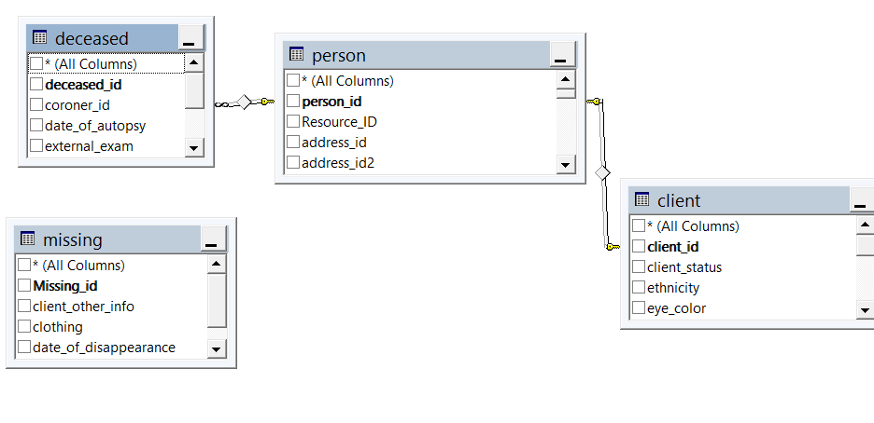

New=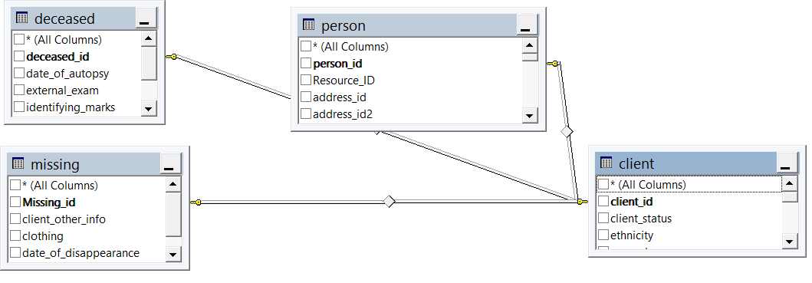

* **campaign – medicine – vaccine**  
  Delete:

Object: campaign.medicine_ID

Relationship: Medicine.medicine_ID -> Campaign.medicine_ID

Add:

Object: Medicine.campaign_ID

Relationship: Campaign. campaign_ID -> Medicine.campaign_ID

OLD=

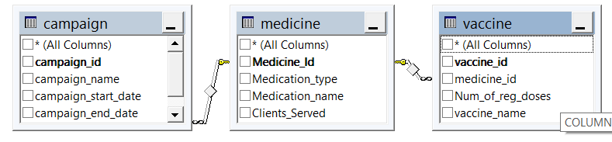

NEW= 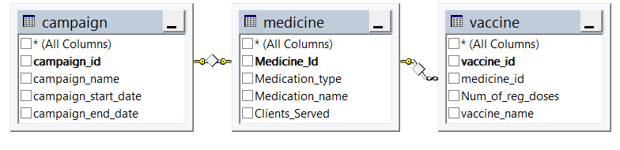

* **Disaster_Encounter – Location – Address**

Delete:

Object: Disaster_Encounter.Address_ID

Relationship: Disaster_Encounter.Address_ID -> Address.address_ID

OLD=

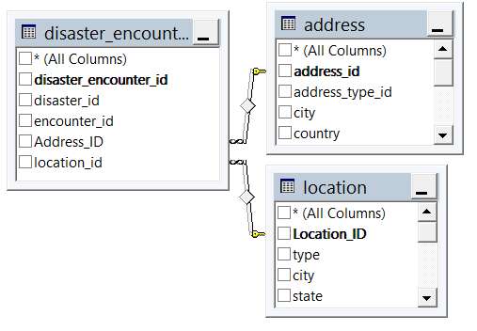

New=

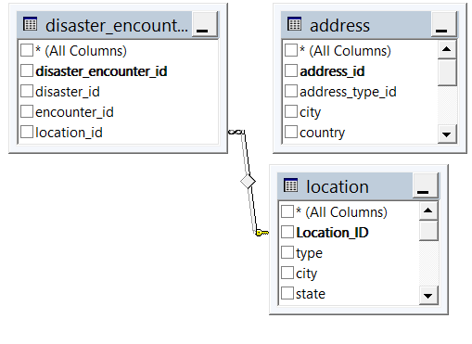

* **Encounter_client_vaccine**

Rename:

Object: medicine to Current_Client_Medicine

OLD=

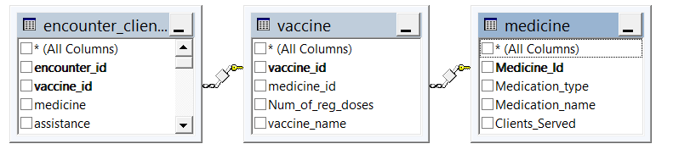

New=  
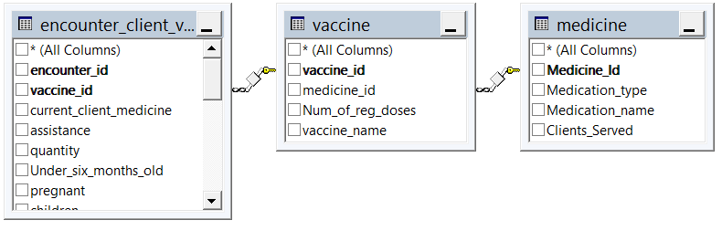

* **Pet – Pet_Deceased - Pet_Missing**

Delete:

Objects: Pet.Pet_Deceased_ID and Pet.Pet_Missing_ID

Relationships: Pet.Pet_Deceased_ID -> Pet_Deceased.Pet_Deceased_ID

And Pet.Pet_Missing -> Pet_Missing.Pet_Missing_ID

Add:

Relationships: Pet.Pet_ID -> Pet_Deceased.Pet_Deceased_ID

And Pet.Pet_ID -> Pet_Missing.Pet_Missing_ID

OLD=

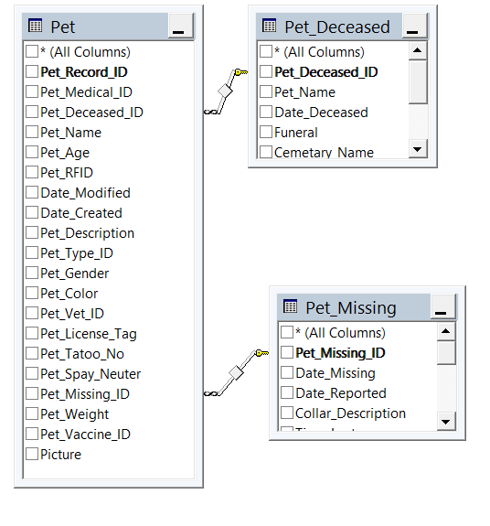

New=

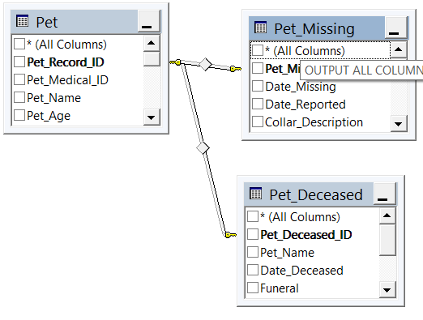

* **Pet – Pet_Vaccine**

Delete:

Object: Pet.Medical_ID and Pet_Vaccine.Pet_Record

Relationship: Pet.Pet_Record_ID -> Pet_Vaccine.Pet_Record_ID

Add:

Relationship: Pet.Pet_Vaccine_ID -> Pet_Vaccine.Pet_Vaccine_ID

(delete Pvaccine table??)

OLD=

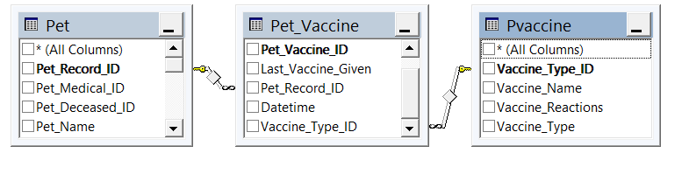

New=

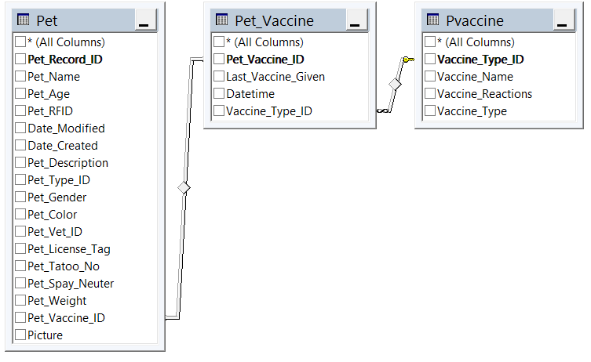

* **Services – all subtypes**

Add:

Relationships:

Job.Job_ID = PK/FK Service.service_ID

Medicine.Medicine_ID = PK/FK Service.service_ID

Emergency_Medical_ID = PK/FK Service.service_ID

Transportation.Transportation_ID = PK/FK Service.service_ID

House.House_ID = PK/FK Service.service_ID

Food.Food_ID = PK/FK Service.service_ID

OLD=

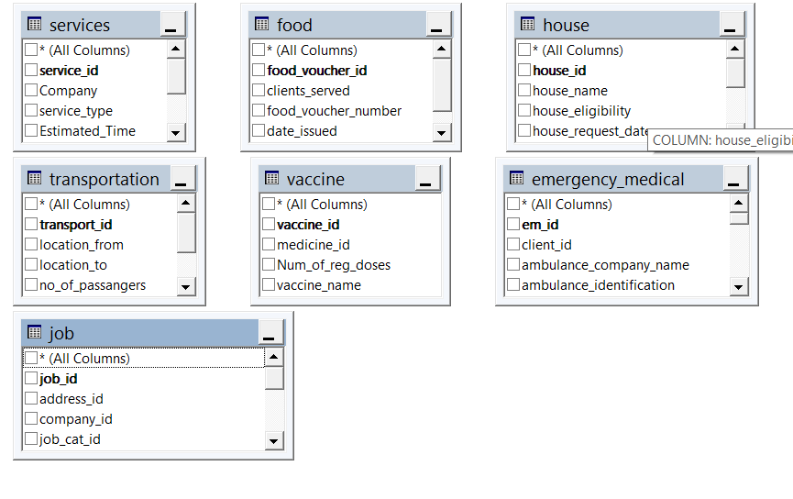

New=

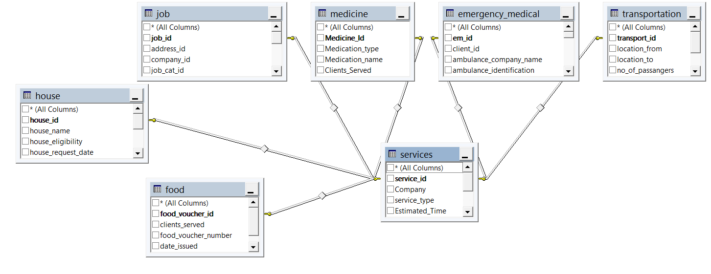

* **Property – Case_Client – Case_Intake**

Delete:

Relationship: Property.Case_ID -> Case_Intake.Case_ID

OLD=

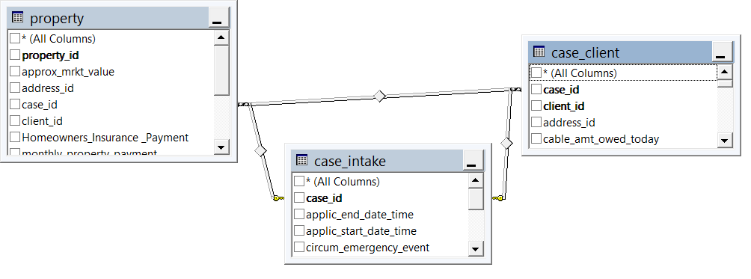

New=

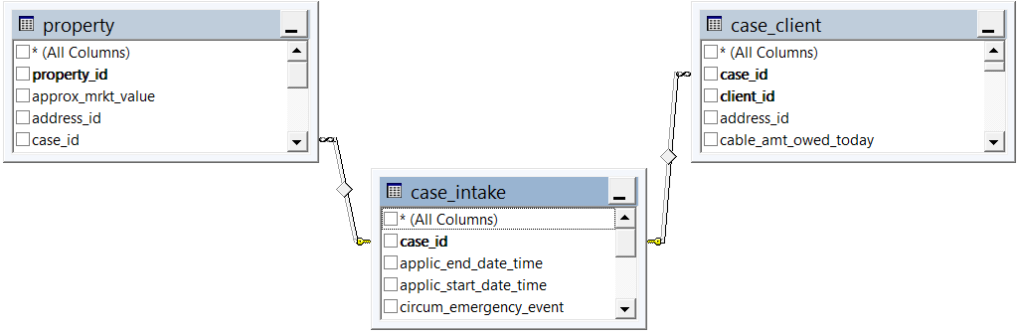

* **Products - Fema**

Delete:

Object: Products.FEMA_ID

Relationship: Products.FEMA_ID -> FEMA.FEMA_ID

Add:

Relationships: Products.Product_ID -> FEMA.FEMA_ID

OLD=

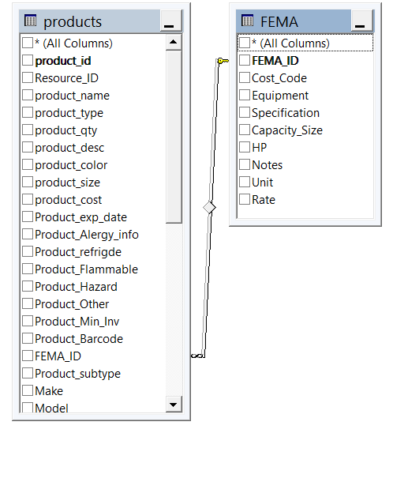

New=

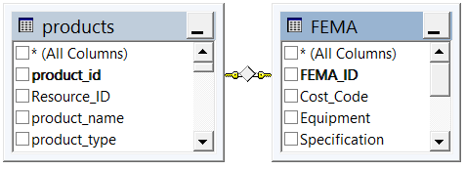

* **Case_Client**

Delete:

Relationship: Case_Client.Case_ID -> Case_Client.Case_ID

And Case_Client.Client_ID -> Case_Client.Client_ID

OLD=

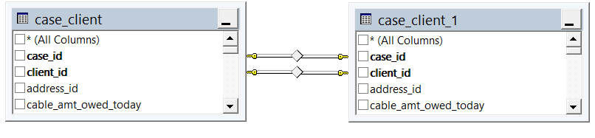

New=

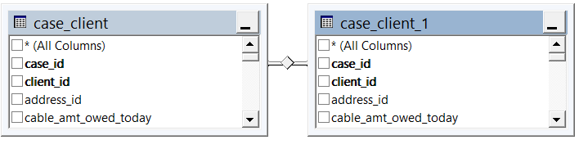

Dustin- Products

* Product_exp_date = datetime
* Prod_Barcode = varcar max
* Fix GPS